Title of the Papers (13pt, times new roman, bold, centered)

Author’s Name^{1*}, Author’s Name², Author’s Name³,... (Capital, 10pt, times new roman, centered)

¹Department, University, Country (10pt Times New Roman, centered)
²Department, University, Country (10pt Times New Roman, centered)
³Department, University, Country (10pt Times New Roman, centered)

*youremailaccount@xxx.xxx.xx (10pt Times New Roman, centered)

Abstract
This is a sample of the format of your full paper. Use Word for Windows (Microsoft) (or an equivalent Word Processor with the same "printing results"). Use single space. Use 10pt, Times New Roman. The abstract should be informative. It should be self-explanatory without reference to the text of the manuscript. It should include essential, significant results that support the conclusion of the work. Three to six keywords not used in the title should also be provided. Abbreviations should not be used in the abstract.
Keywords: Leave one blank line after the Abstract and write your Key-Words (4 - 6 words)

Introductions
The introduction should be comprehensible to the general reader. Give a clear statement of the purpose of the paper and provide relevant context to support the basis for the paper and the significance of the work. Do not exhaustively review the literature.

Materials and Methods
Material & methods provide sufficient information in the text or by reference to other work to permit the submitted work to be repeated without the need to communicate with the authors. Relevant validity and reliability data should be provided for critical methods. State the type of statistical tests used. Include the number of observations and the statistical findings when appropriate. Parametric and nonparametric statistics must be used as appropriate.
The main contents which are to be presented:
Participants
Procedure/Test protocol/Skill test trial/Measure/Instruments
Data collection and analysis / Statistical analysis

Results
Results should be presented precisely and should not contain material that is appropriate for the discussion. Units, quantities, and formulas should be expressed according to the International System (SI units). All measurements should be given in metric units.
Table1. The Anthropometric data of Indonesian National Team Players
No. | Names | Height (cm) | Weight (kg) | BMI | Category
1 | Marcelino Ferdinand | 170 | 70 | 24,2 | Ideal
2 | Rizki Ridho | 180 | 75 | 23,1 | Ideal

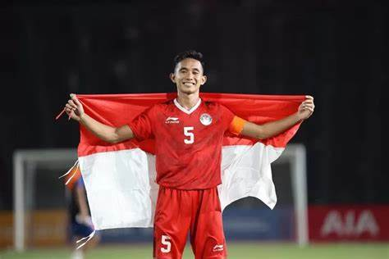
Figure 1. Nasional Team Player Named Rizki Ridho

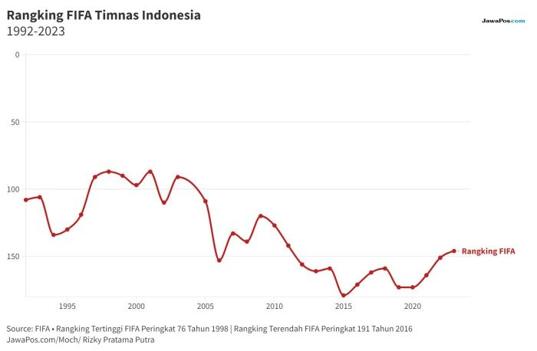
Diagram 1. Indonesian National Team Rangking FIFA

Discussion
Emphasize the new and important aspects of the study and conclusions derived from the study.

Conclusions
Or logical consequence. Your conclusion is your chance to have the last word on the subject. The conclusion allows you to have the final say on the issues you have raised in your paper, to summarize your thoughts, to demonstrate the importance of your ideas, and to propel your reader to a new view of the subject. It is also your opportunity to make a good final impression and to end on a positive note.

Conflicts of interest - If the authors have any conflicts of interest to declare.

References: (APA Style, Mendeley)
The minimum number of references is 30 recent articles (maximum of the last 10 years), originating from international articles (80% suggestion) and national articles (20% suggestion)

